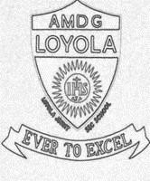
LOYOLA JESUIT SECONDARY SCHOOL
2026 JUNIOR CERTIFICATE MOCK EXAMINATION
PHYSICS
(100 marks)
Subject Number: J022
Date : ____________ Time Allowed: 2 hours
8:00 – 10:00 am
Question Number | Tick if answered | Do not write in these columns
1-20
21
22
23
24
25
26
27
28
29
30
31
 | Total
Instructions

- This paper contains 12 printed pages. Please check.
- Fill in your name at the top of each page.
- This paper has three sections A, B and C. For Section A, encircle the letter representing the right answer to each question. Sections B and C should be answered in the spaces provided.
- Answer all the 31 questions.
- Use of standard electronic calculators is allowed.
- In the table provided on this page, tick against the number of the question you have answered.
- Hand in your paper to the invigilator when time is called to stop writing.

Turn over

SECTION A (20 marks)
Multiple Choice
Answer all questions in this section by circling the correct answer. Each question carries 1 mark.

- Which of the following stages comes at the end during scientific investigation?
- inquiry
- conclusion
- observation
- hypothesis

- What is the direction of magnetic field lines in a bar magnet?
- North to West
- North to South
- South to West
- South to North

- Which of the diagrams in figure 1 are correctly drawn to represent electric field for a point charge?

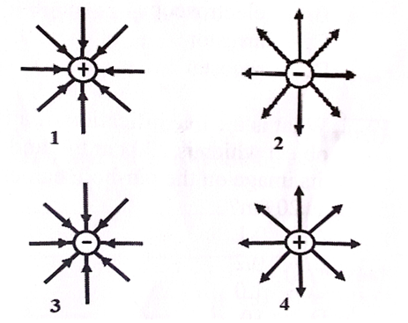

Figure 1

- 1 and 2
- 1 and 3
- 3 and 4
- 2 and 4

- A charge of 10 C flows through a wire in 2 seconds. The current flowing is _______________.
- 200 A
- 200 C
- 2 A
- 2 C

- Which of the following is the density of a substance which weighs 200g and its volume is 40cm³?
- 0.5 g/cm³
- 5.0 g/cm³
- 80 g/cm³
- 120 g/cm³

- What is the meaning of the symbol shown in figure 2?

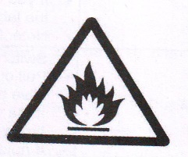
Figure 2
- Danger
- Flammable
- Irritant
- Laser beam

- The SI unit of mass is
- gram
- ampere
- ton
- kilogram

- Which of the following is the reason why Illala ship floats on the waters of lake Malawi?
- its mass is higher than that of water.
- its mass is less than that of water.
- Its average density is lower than that of water.
- its density is higher than that of water.

- An ammeter is always connected in ____________ with the components in a circuit.
- Series
- Phase
- Perpendicular
- Parallel

Figure 3 shows a coin placed in water. Use it to answer questions 10 and 11.

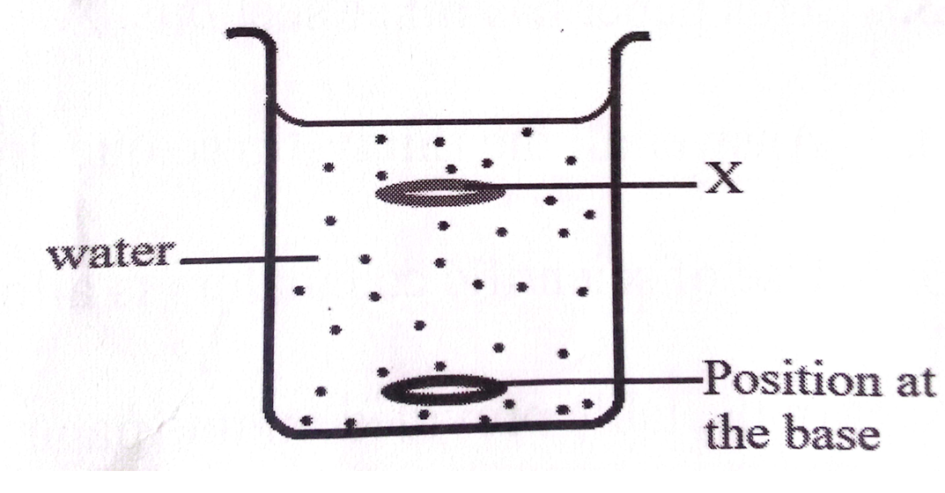
Figure 3

- Which of the following best describes the position of coin image at X?
- real depth
- high depth
- low depth
- apparent depth

- Why does the coin appear to be nearer the surface at position X?
- because of diffraction
- because of reflection
- because of refraction
- because of deflection

Figure 4 shows two bar magnets. Use them to answer questions 12 and 13.

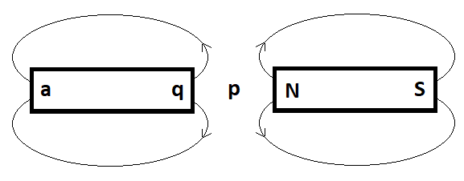
Figure 4
- What is the magnitude of the resultant force experienced by an object placed at point P?
- very large
- very small
- medium
- zero

- What is the pole marked q?
- north pole
- south pole
- both North seeking and South Seeking pole
- neutral
- A spring balance measures __________.
- volume of the object
- mass of the object
- weight of the object
- turning effect of a force

- What type of machine is a pair of scissors?
- lever
- wedge
- pulley
- inclined plane

- Liquids that conducts electricity are called ___________.
- conductors
- electrolytes
- electrodes
- fluids

- The SI unit in symbols of heat capacity is _______.
- Kg/K
- J/K
- N/kg/k
- W/kg/k

- A radioactive nucleus emits a β particle. What happens to the proton number of the nucleus?
- It stays the same
- It increases by 1
- It decreases by 4
- It decreases by 2
Figure 5 is graph of mass against volume of a metal. Use it to answer questions 19 and 20.

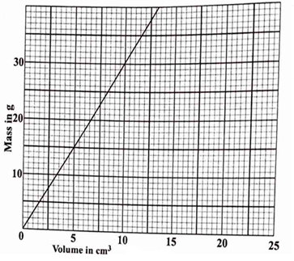

Figure 5

- What is the relationship between mass and volume.
- as mass increases volume increases proportionally.
- as mass increases volume decreases proportionally.
- as mass increases volume remains the same.
- as mass decreases volume increases.
- From the graph, what is the volume of 18g mass of the metal?
- 5 cm³
- 6 cm³
- 7 cm³
- C

SECTION B (50 marks)

Answer all questions in the spaces provided

- a. Define “a test charge”.
_______________________________________________________________________________________________________________________________________________( 1 mark)

b. Figure 6 shows two charged bodies P and N. If small charges T and U are placed in the fields of P and N respectively, draw, on the same diagram, the direction of force and electric field on charges T and U.

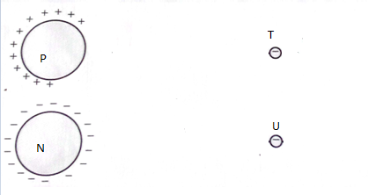

Figure 6
(4 marks)

c. State the law of charges.

___________________________________________________________________________________________________________________________________________________________________________________________________________________________________(2 marks)

- a. What does the phrase “rectilinear propagation of light” mean?
_______________________________________________________________________________________________________________________________________________________________(1 mark)
b. A pinhole camera of length 20 cm is used to view the image of a tree of height 10 m which is 30 m away from the pinhole. Calculate the height of the image of the tree obtained on the screen.

(3 marks)

- a. State three safety rules and regulations when handling chemicals in a laboratory.
__________________________________________________________________________________________________________________________________________________________________________________________________________________________________________________(3 marks)
- Describe one response of emergency fire outbreak
______________________________________________________________________________________________________________________________________________________________(2 marks)
- a . State the SI unit of power. _____________________________________________________________________________(1 mark)

b . Give any two similarities between alpha particles and beta particles in terms of their properties.
__________________________________________________________________________________________________________________________________________________________________ (2 marks)

- Given a nuclear notation ${}_{92}^{238}U$, identify the following:
- Mass number
____________________________________________________________________________________________________________________________________________________________
(1 mark)
- Atomic number
____________________________________________________________________________________________________________________________________________________________
(1 mark)
- a. Define “anomalous expansion”
__________________________________________________________________________________________________________________________________________________________________ (2 mark)
- A lever has a velocity ratio of 4 and a mechanical advantage of 3, calculate the efficiency of the lever.

(3 marks)
- A cube of a metal has a density of 9.0 g/cm³. Express this density in kg/m³.

(3 marks)

- a. Which state of matter can be described as
- keeps own shape, density- high to very high.
____________________________________________________________________
(1 mark)
- Compressed a great deal, takes shape of container.
____________________________________________________________________ (1 mark)
b. Using kinetic theory of matter, explain why a sweet melts when it is put in the mouth. ________________________________________________________________________ ________________________________________________________________________ ________________________________________________________________________ (3 marks)
c. Calculate work done if an object of mass 200g is dropped from a height of 0.4m to the ground.

(3marks)
- a . define “specific heat capacity”.
___________________________________________________________________________________________________________________________________________________________________(2 marks)
b. Calculate the heat energy required to raise the temperature of 2.5 kg of aluminium from 20 ºC to 40 ºC, if the specific heat capacity of aluminium is 900 J/kgK.

(3 marks)
c .State three advantage of frictional force. ___________________________________________________________________________________________________________________________________________________________________________________________________________________________________________________(3 marks)

- a. Figure 7 is a diagram of a mirror and a ray of light that bounces off the mirror

. 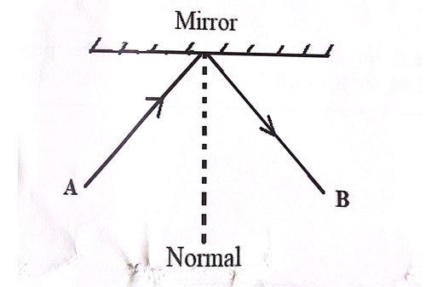

Figure 7

- Name the rays labeled A and B
A:_____________________________________________________________________________
( mark)
B:_____________________________________________________________________________
(1 mark)
- If the angle of incidence is 45◦, what will be the angle of reflection?
________________________________________________________________________________
(1 mark)
b. State two characteristics of images formed by plane mirrors.
__________________________________________________________________________________________________________________________________________________________________________________________________________________________________________________________(2 marks)

SECTION C (30 marks)
Answer all questions in this section.

- a. With the aid of a diagram, describe how a solar eclipse is formed.

___________________________________________________________________________________________________________________________________________________________________________________________________________________________________________________________________________________________________________________________________________________________________________________________________________________________________________________________________________________________________________________________________________________________________________________________________________________________________________________________________________________________________________________________________________________________________________________________ (6 marks)

b. Explain the effect of changing length of a wire on its electrical resistance.
____________________________________________________________________________________________________________________________________________________________________________________________________________________________________________________________________________________________________________________________________________________________________________________________________________________________________________________________________________________________________________________________________________________________________________________________________________________________________________(4 marks)
- a. Explain how a lightning arrestor protects tall buildings from the effect of lightning.
__________________________________________________________________________________________________________________________________________________________________________________________________________________________________________________________________________________________________________________________________________________________________________________________________________________________________________________________________________________________________________________________________________________________________________________________________________________________________________________________________________________________________________________________________________________________________________________________________________________________________________________________________________________________________________________________(4 marks)
b. Explain how radioactivity is applied in
(i) Industries __________________________________________________________________________________________________________________________________________________________________________(2 marks)
(ii) Archaeology __________________________________________________________________________________________
________________________________________________________________________________(2 marks)

(iii)Medicine _________________________________________________________________________________________________________________________________________________________________________ (2 marks)
- a. Describe an experiment that can be carried out to illustrate dispersion of white light.
______________________________________________________________________________________________________________________________________________________________________________________________________________________________________________________________________________________________________________________________________________________________________________________________________________________________________________________________________________________________________________________________________________________________________________________________________________________________________________________________________________________________________________________________________(5 marks)
b. describe an experiment that can be conducted to show magnetic field pattern due to a straight current carrying conductor.
____________________________________________________________________________________________________________________________________________________________________________________________________________________________________________________________________________________________________________________________________________________________________________________________________________________________________________________________________________________________________________________________________________________________________________________________________________________________________________________________________________________________________________________________________________________________________________________________(5 marks)

END OF QUESTION PAPER

